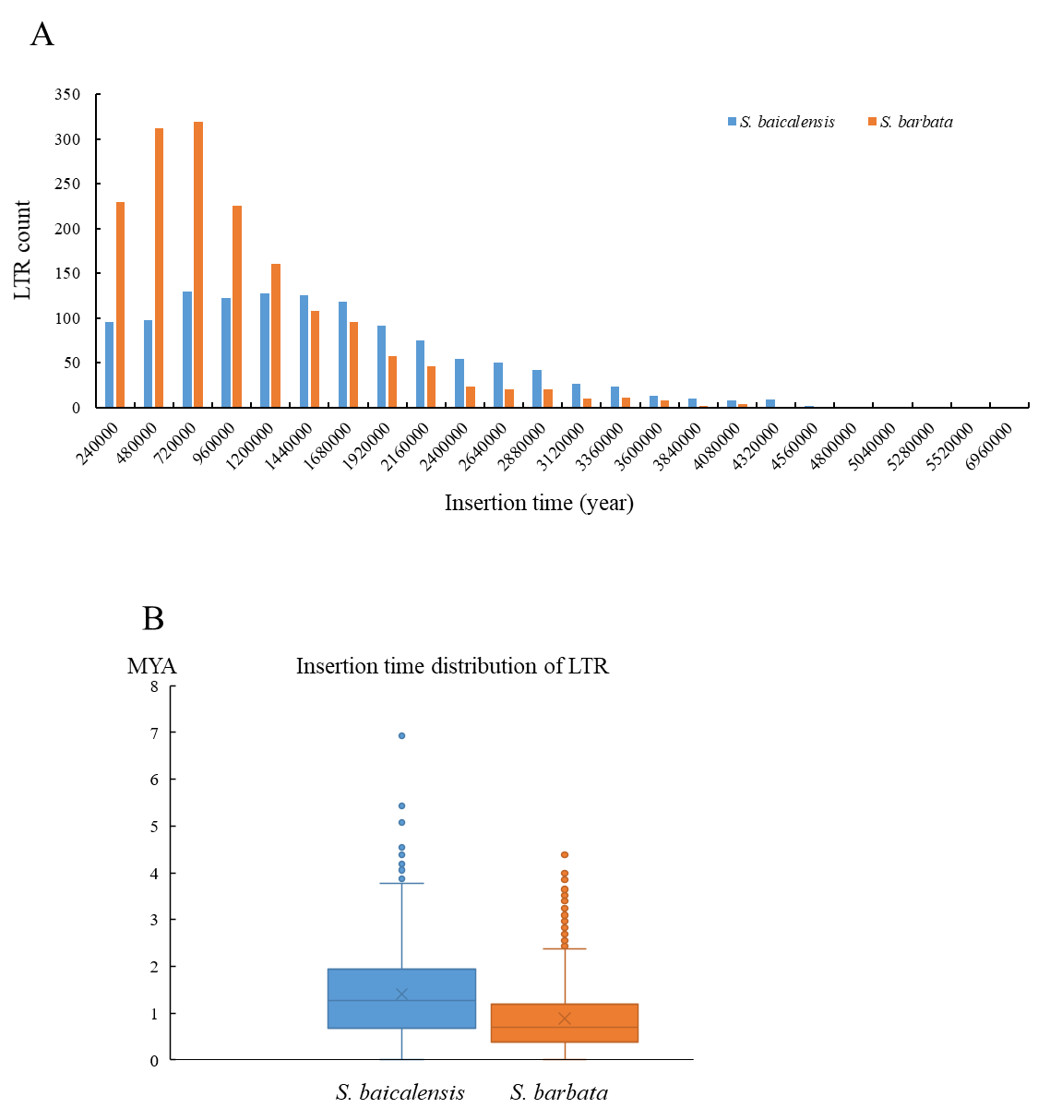

Supplementary Figure S5. Insertion time distribution of intact LTR-RTs in*S. baicalensis* and *S. barbata* assuming a mutation rate of *μ*=1.3×10-8 (per bp per year).